# 

# 

# 

# PATAN COLLEGE FOR PROFESSIONAL STUDIES

# Individual Reflective Report

# Python Project

# 

# Shahu: The Ultimate Shared Power(Group 10)

# PROJECT REPORT

# Submitted by Submitted to

# Dinesh Timalsina (1815429) UOB (Luton)

**Individual Report:**

Pursuing programming was always my passion and after passing my intermediate level, I was in dilemma of choosing the course which will help my passion to be my profession. After lots of research I made my mind to get enrolled in this course offered by University of Bedfordshire. I already know that this course is all about developing software. In level 4 SEM –I, University of Bedfordshire assigned the python group project Shared Power.

|  |  |  |  |
| --- | --- | --- | --- |
| Student Number | First Name | Last Name | Group No |
| 1815429 | Dinesh | Timalsina | B |

Before the group has been chosen I fell overexcited to work with the members of the group. Working with the group members: Ram Ghimire, Anupam Dhakal and Kshitij Bajagain was one of the best part in my life. We were been friends before but we hadn’t worked with each other in group. Group work was been a very different job for me but in this project group work is the most.

Group division was another most important work that my friend Anupam Dhakal had properly divided work among all of the members of the group. According to that group role my role was a tester and also a coder and I have put my maximum effort on proving my group role as a developer. Following group division was assigned in group:

|  |  |  |
| --- | --- | --- |
| **S. N** | **Name** | **Work Division** |
| **1.** | Kshitij Bajagain | Brainstorms, User Panel ,Upload Tools , Search Tools,, Hire Tools, Class Diagram, File handling(FH) |
| **2.** | Anupam Dhakal | Research, Login , Register, UML Diagrams(Sea level, Fish Level), Presentation Slides |
| **3.** | Dinesh Timalsina | Return Tools, Payment , Invoice Generation, Clam level Diagram, Testing of software |
| **4.** | Ram Prasad Ghimire | Insurance agent profile design and development, Activity diagram, Analysis of software |

I think that all of the members of my group worked hard in their respective jobs and helped me in my coding part of return tools and invoice generation. Every member has done their job perfectly but especially during development phase of software, some confusion was there but it was over after some group discussions. I did not find any bad qualities in them which hampered our project. Additionally, I got to know a lot of things about myself during this project. I realized that I work more effectively in a group than alone

Below I have attached the work that I have done during software development.

1>**Coding Part:**

My role during software development was a coder; I developed Return Tool and Payment Tools for registered user. Similarly, the functions used by return tool and payment tool has also been done by me. The GUI part of those Return Tool and Payment Tool is also done by me.

**2>UML Diagrams:**

As per the work division, I did Clam Level Diagram of the Use Case that was assigned to me by group leader Anupam Dhakal.

Not every project is completely easily and run without any problems. Since there were some problems regarding printing the invoice every month at the earlier days but I was successful in solving this problem by recommending some techniques from my tutors and my group members. All members in my group helped me to solve some of the minor issues that arose during the time of the project. The major problem I faced during the project was to introduce class concept to GUI part of programming. I took help from the mentors and group members to clearly describe me how it works and what does the errors meant. With the help of class diagrams, I was able to understand it clearly.

In group, every member worked perfectly and evaluating their work I have attested a table below which rates their work during project development.

|  |  |  |  |
| --- | --- | --- | --- |
| Student Number | First Name | Last Name | Contribution  (N,S,I) |
| 1723333 | Kshitij | Bajagain | S |
| 1816707 | Ram | Ghimire | S |
| 1815430 | Anupam | Dhakal | S |

**S** -Significant (The group member’s work was integral to the overall submission)

**N** -No Contribution (The group member took no part in the project submission)

**I** -Insignificant (The group member’s work made little difference to the overall submission)

In conclusion, Shared Power project is been one of the best group projects that I have ever done. All of the group members were good at communication with each other and there was a good programming environment in our group. Group working has been new experience for me but it has very much impact in my career.

**UML DIAGRAMS (Clam Level):**

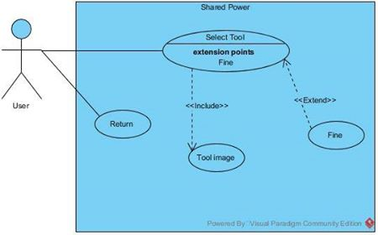

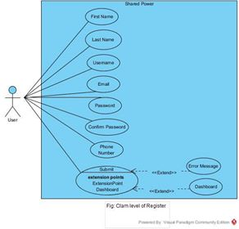

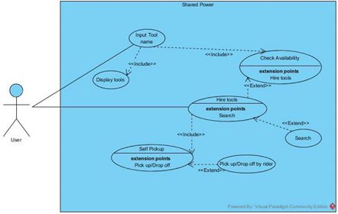

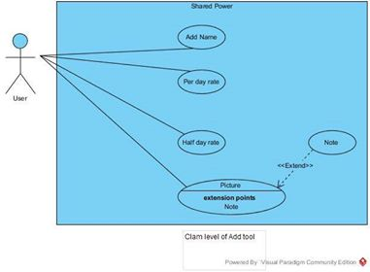

Snippets of Code:

